Day45

Code –//{ Driver Code Starts

#include<bits/stdc++.h>

using namespace std;

// } Driver Code Ends

class Solution{

public:

vector<int> downwardDiagonal(int N, vector<vector<int>> A)

{

vector<int> ans;

for(int j=0;j<N;j++){

int i=0, k=j;

while(i<N && k>=0){

ans.push_back(A[i][k]);

i++, k--;

}

}

for(int i=1;i<N;i++){

int j=N-1, k=i;

while(k<N){

ans.push_back(A[k][j]);

k++, j--;

}

}

return ans;

}

};

//{ Driver Code Starts.

int main()

{

int t;

cin >> t;

while(t--)

{

int n;

cin >> n;

vector<vector<int>> A(n, vector<int>(n));

for(int i = 0; i < n; i++)

for(int j = 0; j < n; j++)

cin >> A[i][j];

Solution obj;

vector<int> ans = obj.downwardDiagonal(n, A);

for(auto i:ans)

cout << i << " ";

cout << "\n";

}

return 0;

}

// } Driver Code Ends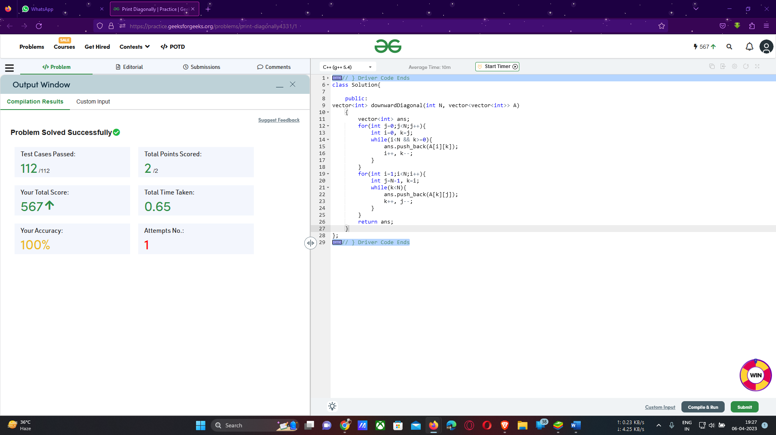----------------------------------------------------------------------------------------------------------

Time complexity – O(n)

Space complexity- O(1)

------------------------------------------------------------------------------------------------------------------------------------